Practicum Report

Job sheet 3

Assignment 3: Experiment

Variables, Data Types, and Operators



MUHAMMAD BAIHAQI AULIA ASY’ARI

2241720145

CLASS 1I (INTERNATIONAL)

INFORMATICS ENGINEERING­­

INFORMATICS TECHNOLOGY

STATE POLYTECHNIC OF MALANG

Contents

Experiment 1 2

Experiment 2 2

Experiment 3 2

Assignment 3

# Experiment 1

1. Mention sequentially what you do after college like experiment 1 question-1!

Answer :

* janjksdnask

1. Rewrite and complete the algorithm in Experiment 1 No. 2!
2. Calculate mathematically the results of experiment 1 problem 3! What is the result?
3. If there is additional information as follows
4. "Mr. Ahmad wants to plant a circular rose in the middle of his land. Pak Ahmad wants to maximize his land so that as much as possible there are only a few vacant lands. What is the area of Mr. Ahmad's land planted with Mawar flowers? "
5. Rewrite the steps for making the correct algorithm!
6. After additional data about question 4, what is the area of Mr. Ahmad's land that is not planted with roses?

# Experiment 2

# Experiment 3

# Assignment

1. Input : Stamps

Process :

* Put the stamp number 6
* Put the stamp number 2
* Put the stamp number 5
* Put the stamp number 4
* Put the stamp number 3
* Put the stamp number 1

Output : Lina’s painting

1. Input : Wheel, Yellow Frame, Blue Frame, Red Handle Bar, Green Handle Bar, Gray Handle Bar, Orange Saddle, Yellow Saddle, Purple Saddle, Gray Saddle, Black Saddle

Process :

* Start with the wheel
  + For bike A, B, and C go to the yellow frame route
    - For bike B, and C go to Gray Handle Bar
      * For bike B go to Orange Saddle
        + But the Orange Saddle doesn’t exist in the Gray Handle Bar route
      * For bike C go to Gray Saddle
    - For bike A go to Red Handle Bar
      * Go to Orange Saddle
  + For bike D go to blue frame
    - Go to Grey Handle Bar
      * Go to Purple Saddle

Output : Bike B

1. Input : 5 Person Biodata

Process :

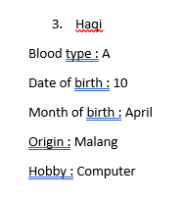 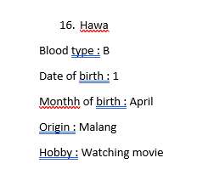 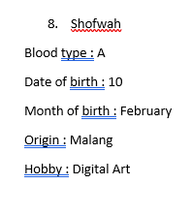 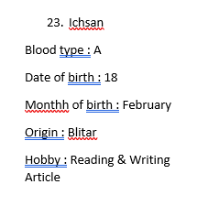 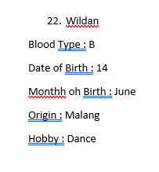

Output :

* Who has the same blood type as you?
  + Ichsan and Shofwah
* Who were born in the same month as you?
  + Hawa
* Who was born on the same date as you?
  + Shofwah
* Who are from the same area as you?
  + Hawa, Shofwah, and Wildan
* Who has the same hobby as you?
  + No one

1. Input :

* Weight from Clothes
  + Ani : 4 kg
  + Budi : 15 kg
  + Bina : 2 kg
  + Cita : 11 kg
* Price per kg of clothing is Rp 4.500
* If the customer washes clothes more than 10 kg, the customer will get a 5% discount

Process :

* Ani : 4 kg * Rp 4.500 = Rp 18.000
* Budi : 15 kg * Rp 4.500 = Rp 67.500 * 95% = Rp 64.125
* Bina : 2 kg * Rp 4.500 = Rp 9.000
* Cita : 11 kg * Rp 4.500 = Rp 49.500 * 95% = Rp 47.025
* Total : Rp 18.000 + Rp 64.125 + Rp 9.000 + Rp 47.025 = Rp 138.150

Output : Profit earned by laundry is